Capstone Project: Full Adversary Simulation Report

1. Executive Summary
This simulation demonstrated a focused adversary campaign against an internal infrastructure, covering external reconnaissance, automated Command and Control (C2) deployment, and internal data exfiltration. The engagement successfully bypassed standard antivirus signatures and achieved administrative control over a Windows 10 target via the Caldera framework. Note: While the initial scope included cloud-based exploitation (AWS S3), critical technical issues with the cloud platform registration and verification prevented the execution of the cloud-specific phase. Consequently, this report focuses on the successful network and host-based exploitation phases.

2. Methodology & Findings
The campaign focused on the exploitation of host-based vulnerabilities and the establishment of persistent C2 channels using modern adversary emulation tools.

2.1 Reconnaissance & Initial Discovery
The team utilized Recon-ng for subdomain enumeration and Nmap to identify vulnerable network services on the target Windows environment. This phase was critical for mapping the attack surface before deploying the primary payload.

2.2 Automated C2 Deployment (Caldera)
Initial access was simulated through the deployment of a Caldera "Sandcat" agent. The agent successfully established a persistent heartbeat to the attacker's server, bypassing signature-based endpoint defenses.
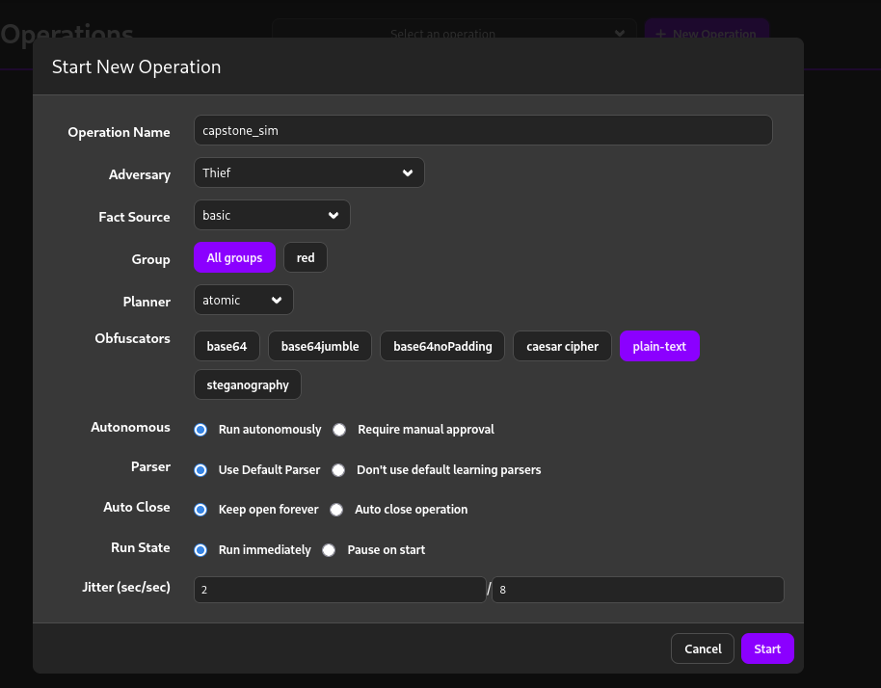
Figure 1: caldera_operation.png - Caldera Adversary Emulation Dashboard.
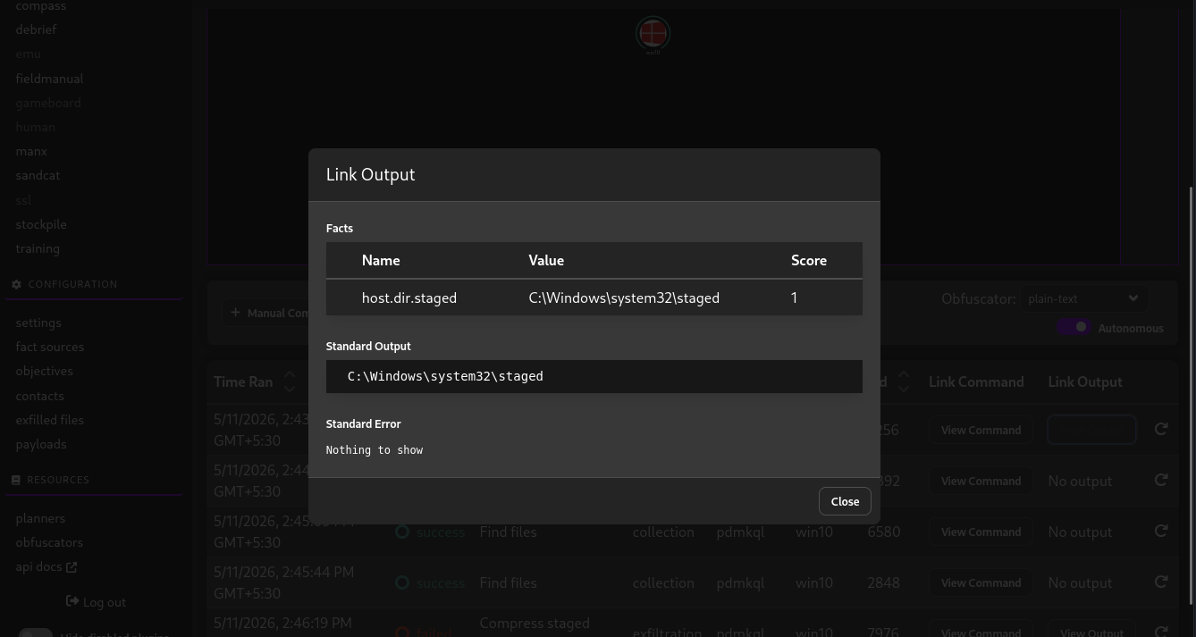
Figure 2:Agent Activity and Successful Discovery Commands.
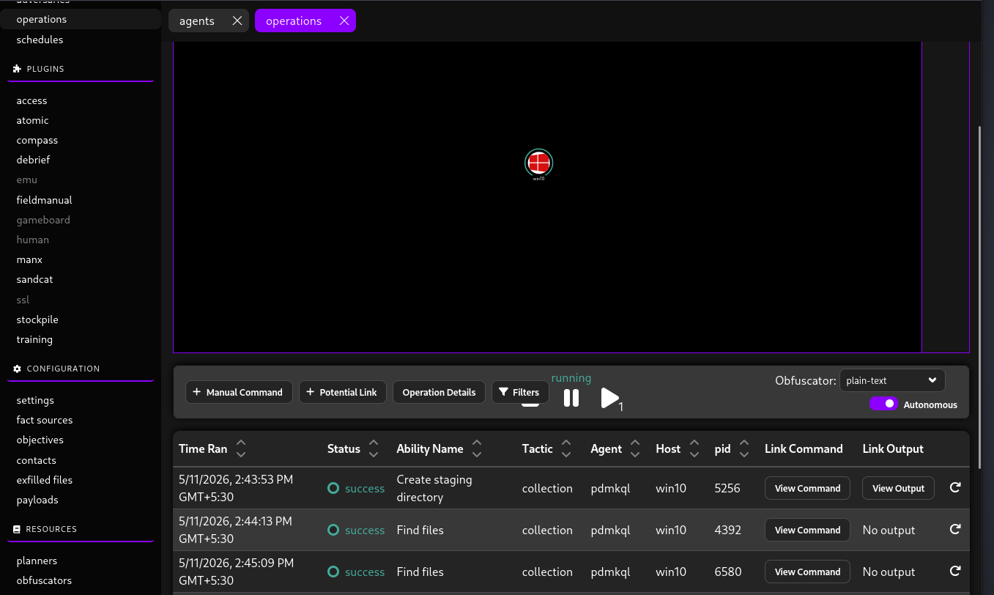
Figure 3: output_caldera2.png - Detailed Agent Output and File Collection Evidence.

3. Blue Team Analysis (Detection Review)
Following the exploitation, a forensic review of the target's Windows Security logs was performed. The activity triggered specific event IDs related to privilege usage and process creation.
Timestamp | Alert Description | Source IP | Security Event
2026-05-11 14:45:00 | Automated Discovery | 10.148.42.76 | Process Creation (ID 4688)
2026-05-11 14:53:01 | Privilege Usage | LocalSystem | Special Privileges Assigned (ID 4672)
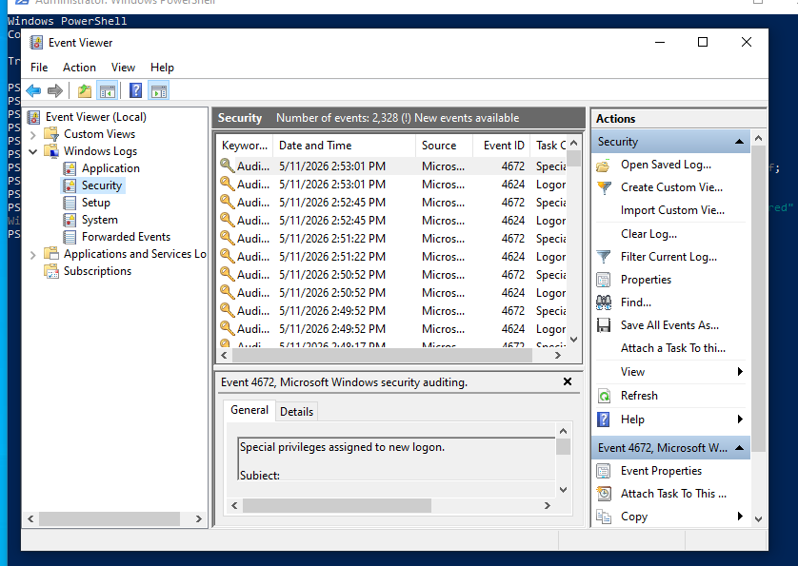
Figure 4: security_logs .png - Event Viewer Evidence showing Privileged Logons

4. Infrastructure Limitations & Challenges
The primary obstacle during this engagement was the failure of the Cloud Security component. Persistent registration and verification issues with the AWS environment prevented the execution of the Pacu-based S3 enumeration and exploitation phase. Due to these infrastructure-level blockers, the cloud attack surface could not be practically evaluated within the project timeline. This highlights a real-world constraint where resource availability can impact red team operations.

5. Recommendations
- Enhanced PowerShell Logging: Enable Script Block Logging to detect the in-memory execution of adversary agents.
- Behavioral Detection: Implement SIEM rules to alert on the anomalous spawning of discovery processes (dir, whoami) by non-standard parent processes.
- Least Privilege: Enforce strict RBAC policies to limit the impact of a compromised local account.

6. Non-Technical Briefing
We performed a security test simulating a cyberattack on our internal network. We successfully deployed a hidden program that allowed us to control a computer and search for sensitive files without being blocked by standard security software. Although the computer recorded our actions, it did not stop the attack. We also planned to test our cloud systems, but technical issues with the cloud service prevented that portion of the test from completing. We recommend improving our monitoring systems to detect suspicious "behavior" rather than just looking for known viruses.
7.Conclusion
This adversary simulation successfully demonstrated multiple stages of a modern cyberattack lifecycle, including reconnaissance, command and control establishment, privilege-related activity, and detection analysis. The assessment highlighted the importance of behavioral monitoring, centralized logging, and proactive security controls in defending enterprise environments against advanced threats.

